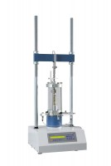 | Digital Tritest 50 Load Frame 110-120vAC  Code: 25-3518/02  Product Group: Digital Tritest 50 Load Frame

Standards
ASTM D1883, ASTM D2166, ASTM D2850, ASTM D4767, ASTM D7181, AASHTO T99, AASHTO T134, AASHTO T135, AASHTO T136, AASHTO T180, AASHTO T193, AASHTO T208, AASHTO T296, AASHTO T297

Further Information
110vAC, 50/60 Hz, 1ø, 300 Watts.
See Data Acquisition section for electronic load and strain measurement options.

Specification
Capacity | 11 ,200 lbf. (50 kN).
Speed Range | English mode: 0.000001 to 0.399999 in/min.  Metric mode: 0.00001 to 9.99999 mm/min.
Rapid Approach Speed | 2.0 in/min. (50 mm/min.).
Platen Travel | 3.9” (100 mm); limit switch protection.
Vertical Clearance | 35 .8” (910 mm) maximum; 12 ” (305 mm) minimum.
Horizontal Clearance | 14 .3” (364 mm).
Serial Interface | RS232 C; programmable baud rate and protocol.
Overall Dimensions | 19.7” w. x 19.7” d. x 57.8” h. (500 x 500 x 1,470 mm).
Weight | Net 220 lbs. (100 kg); Shpg. 300 lbs. (136 kg).

Spares/Consumables
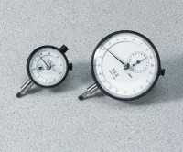 | Dial Indicator - 1.0" Range  Code: 88-4100

