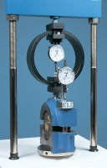 | Breaking Head (Marshall)  Code: 45-6850  Product Group: Accessories for the Marshall test  Complete with gauge disc. Supplied without flow meter.

Standards
EN 12697-34

Further Information
**NOT AVAILABLE FOR SALE IN THE USA**

