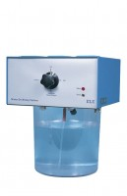 | De-Aired Water Apparatus 15 Litre Capacity  Code: 25-1833/01  Product Group: De-Aired Water  This compact self-contained unit will de-air water quickly and efficiently down to levels of dissolved oxygen acceptable for geotechnical test methods. Air is removed from the water by a vacuum system, which continuously circulates the water in the tank. The unit is supplied with a clear water container, which will hold a maximum of 15 litres of water. Input and output lines are formed using standard 6 mm tube connectors.

