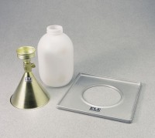 | 4" Sand Density Cone  Code: 29-4292  Product Group: Sand Density Cones  (102 mm)

Standards
ASTM D1556, AASHTO T191

Specification
Top Cone | Threads into sand jug.
Bottom Cone | Flanged to 4-1/2â (114 mm) diam.
Valve | Brass construction; controls sand flow into  density hole.
Sand Jug | Plastic; 1 gal. (4,000 cu. cm) capacity.
Weight | Net 2 lbs. (0.9 kg).

Spares/Consumables
Plastic Sand Jug
Code: 29-4292/10

