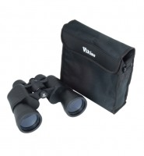 | Binoculars, 10x50  Code: 500-190  Product Group: Surveying Equipment  Centre-wheel focusing and multicoated optics. Particularly suited to twilight and night observations. Supplied complete with carrying case.

