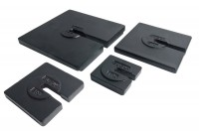 | Set of Weights 100Kg Total Weight.  Code: 25-0408  Product Group: Consolidation Apparatus  9 x 10 kg, 1 x 5 kg, 2 x 2 kg, 1 x 1 kg.

Standards
ASTM D2435, ASTM D4546, AASHTO T216

