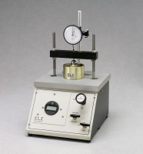 | Pneumatic Consolidation Apparatus  Code: 25-0560  Product Group: Pneumatic Consolidation Apparatus  32 tsf capacity.

Standards
ASTM D2435, ASTM D4546, AASHTO T216

Specification
Construction | Aluminum cabinet with enamel finish; 1â (25 .4 mm) thick aluminum load platform plate; stainless steel  vertical rods.
Maximum Load | 32 tsf.
Required Air Pressure | 123 psi (848 kPa).
Vertical Clearance | 8.25 â (21 0 mm).
Horizontal Clearance | 7.75â (197 mm).
Maximum Piston Travel | 0.5â (12 .7 mm).
Dimensions | 12 â w. x 14 .5â d. x 20.5â h. (305 x 368 x 521 mm).
Weight | Net 48 lbs. (21 .8 kg).

