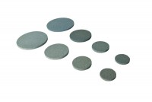 | Porous Disc 100mm Diameter Pack of 2.  Code: 25-7661  Product Group: Accessories for CU/CU effective stress, Tri-Flex 2 Permeability Test Cell, Porous Stones  100 mm diameter porous disc (Pack Of 2).

Standards
ASTM D2850, ASTM D4767, ASTM D5084, AASHTO T296, AASHTO T297, ASTM D7181

