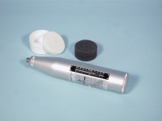 | Standard Concrete Test Hammer  Code: 35-1480  Product Group: Concrete Test Hammer, Surface Hardness  The hammer is intended for testing the quality of concrete in finished structures such as buildings and bridges. Supplied complete with carrying case and carborundum stone, the hammer is suitable for testing concrete with compressive strengths of 10 to 70 N/mm2.

Standards
ASTM C805

Specification
Body | Includes indicator scale, calibration curves.
Calibration Curves | Rebound number vs. compressive strength.
Rubbing Stone | Prepares test surface.
Accuracy | Within 15 %.
Carrying Case | Plastic.
Weight | Net 3 lbs. (1.4 kg).

Spares/Consumables
 | Rubbing Stone  Code: 35-1475/10

