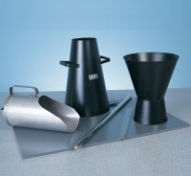 | Tamping Rod 16mm Dia X 600mm Long Hemispherical At Both Ends.  Code: 34-0130  Product Group: Precision Air Entrainment Meter, Slump Test, Accessories for Concrete Moulds  Steel, 600 mm long x 16 mm dia, hemispherical at both ends

Further Information
**NOT AVAILABLE FOR SALE IN THE USA**

