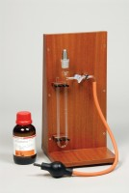 | Blaine Air Permeability Apparatus  Code: 38-1000  Product Group: Blaine Fineness Apparatus, Determination of Fineness Blaine Apparatus

Standards
EN 196-6, EN 459-2, EN 13286-44, BS 4359-2, ASTM C204, AASHTO T153

Specification
Cell | Stainless steel; 12.70 ±0.10 mm i.d.
Disk | 0.9 ±0.1 mm thick with 30-40 one mm diam. holes.
Plunger | Stainless steel.
Manometer | U-tube glass with ground joint, stop cock and rubber  bulb assembly.
Filter Paper | 12.70 mm diam.
Fluid | Pure Mineral Oil.
Weight | Net 7 lbs. (3.2 kg).

Spares/Consumables
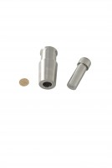 | Blaine Air Permeability Cell  Code: 38-1000/15
 | Filter Paper  Code: 38-0652
Manometer U-tube
Code: 38-1000/10

