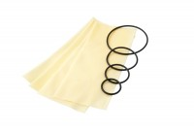 | Rubber Membrane 38mm/1.5 Inch Diameter. Pack of 10.  Code: 25-5061  Product Group: Rubber Membranes  Rubber Membrance For 38Mm/1.5 Inch Samples (Pack Of 10).

