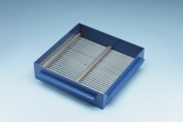 | Grid Sieve 31.5mm Slot Width for EN Aggregate Flakiness Test.  Code: 42-0324  Product Group: Grid Sieves  31.5mm

Standards
EN 933-3

Further Information
**NOT AVAILABLE FOR SALE IN THE USA**
Passing Size - 63 mm Retained Size - 50 mm

