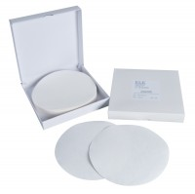 | Filter Papers 150mm Dia Equivalent to Whatman No 1. Box of 100.  Code: 24-9220  Product Group: BS EN CBR mould and acccessories  Box of 100.

Standards
BS 1377, BS 1924, EN 13286-4, EN 1997-2

