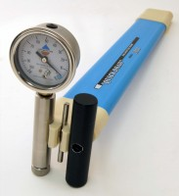 | Quickdraw soil moisture probe 305 mm  Code: 514-010  Product Group: Tensiometers  305 mm long

Further Information
Supplied with coring tool and carrying case.

Spares/Consumables
 | Replacement Dial Gauge.  Code: 514-010/12

