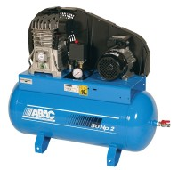 | Air Compressor  Code: 83-1730/01  Product Group: Air Compressors, Air/Water Pressure Systems - up to 1000 kPa

Further Information
**NOT AVAILABLE FOR SALE IN THE USA**

Specification
Dimensions (l x w x h) | 483 x 457 x 864 mm
Free air delivery | 2.0 cfm
Receiver capacity | 50 litres
Maximum pressure | 1000 kPa
Continuous working pressure | 700 kPa
Electrical supply | 220 – 240 V AC  1 ph 50 Hz
Water Trap | No
Weight | 57 kg

