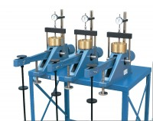 | Floor Mounting Stand.  Code: 25-0429  Product Group: Consolidation Apparatus, Table Top Consolidation Apparatus  A versatile modular steel stand. Holes in the shelf are provided for  securing up to three EL25-0402 Consolidation Frames. Dimensions 610 x 915 x 865 mm (l x w x h).

Standards
ASTM D2435, ASTM D4546, AASHTO T216

