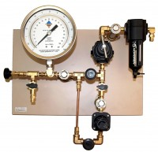 | Low Pressure Manifold  Code: 532-110  Product Group: Pressure plate extractors  Precise low pressure control used to regulate pressure from compressor to extractor.

