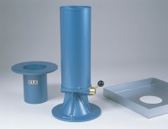 | Metal Tray 300mm Sq X 40mm Deep with A 150mm Dia Hole.  Code: 29-4140  Product Group: Sand Replacement

Standards
BS 1377, BS 1924

