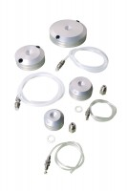 | Pressure Pad 38mm/1.5 Inch Diameter.  Code: 25-5050  Product Group: Pressure Pads  38 mm / 1.5 Inch diameter pressure pad. The pad shall have two empty ports and will come complete with two blanking plugs, plastic tubing and connector. Suitable For both drained and undrained tests.

Standards
ASTM D2850, ASTM D4767, ASTM D7181, AASHTO T296, AASHTO T297

