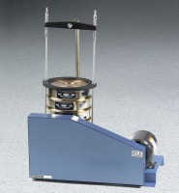 | Sieve Shaker - Motorized 220V 50 Hz  Code: 80-0445/01  Product Group: Laboratory Sieve Shakers  220vAC, 50 Hz, 1ø.

