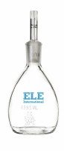 | Glass Specific Gravity Bottle - 250 ml Capacity  Code: 88-6306  Product Group: Glass Specific Gravity Bottles

Standards
ASTM D854, AASHTO T100

