 | Weights for Harvard Trip Balance  Code: 78-7110  Product Group: Mechanical Balances, Harvard Mechanical Trip Balance

Standards
ASTM class 6

Further Information
**Not available for sale in the USA**

Spares/Consumables
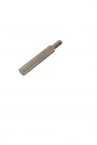 | Consistency Plunger  Code: 38-2010/10

