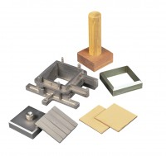 | Porous Plate 60mm Sq.  Code: 26-2181/10  Product Group: Shear Box Assemblies, Shear Box Assemblies

Standards
ASTM D3080, AASHTO T236

Spares/Consumables
 | 2.42" Diameter Porous Stone  Code: 26-2223/10
Porous Plate 2.5 Inch Diameter
Code: 26-2213/10

