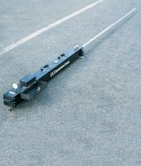 | Benkelman Beam  Code: 47-1460  Product Group: Benkelman Beam, Benkelman Beam

Standards
AASHTO T256

Further Information
Complete with Dial Gauge 25 mm tavel x 0.02 mm divisions.

Specification
Dimensions: Main Body (length), Arm (telescopic) extended, Operating length fully extended | 1397 mm, 2400 mm, 3700 mm
Beam fulcrum ratio | 2:1
Weight | 15.9 kg
Main Body | 55 â (1,397 mm) long, black finish aluminum.
Probe Beam | Aluminum, 8 ft. (2.4 m) long, telescopes into case for storage.
Probe Fulcrum | Ball pivot bearing, gives lever ratio of 2:1.
Vibrator System | Operating switch mounted on top of instrument section (requires 4 âDâ size batteries).
Dial Indicators | Compensated for direct reading (not included).
Leveling Wheel | Adjusts beams to proper elevation.
Open Length | 12 ft. (3.7 m) l.
Weight | Net 29 lbs. (13.2 kg).

