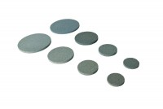 | Porous Disc 70mm Diameter Pack of 2.  Code: 25-6561  Product Group: Accessories for CU/CU effective stress, Porous Stones, Tri-Flex 2 Permeability Test Cell  70 mm diameter porous disc (pack of 2).

Standards
ASTM D2850, ASTM D4767, ASTM D5084, AASHTO T296, AASHTO T297, ASTM D7181

