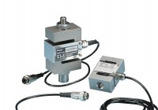 | S-Type Load Cell 5 kN.for Triaxial Tests. Fitted with 5 Pin Din Plug.  Code: 27-1551  Product Group: Load Measurement, Load Measurement  •Repeatability better than ± 0.02% of rated output  •Non-Linearity better than ± 0.03% of rated output  •Supplied complete with 5-pin DIN type connector for connection to GDU  Ideally suited for a wide range of applications, ELE S-type load cells provide high accuracy and minimum deformation. Various models are available, with the necessary adaptors, for use with ELE Triaxial Load Frames, Multiplex 50/Marshall Test 50/CBR Test 50 and Direct Shear machine.

