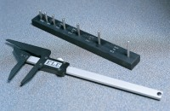 | Length Gauge  Code: 42-0820  Product Group: Elongation Index  Manufactured to the dimensions specified in BS 182.

Standards
BS 812-105

Further Information
**NOT AVAILABLE FOR SALE IN THE USA**

