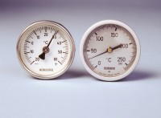 | Portable Thermometer 0 - +250°C  Code: 82-5248  Product Group: Portable Dial-type Thermometers  Complies with BS 598 for temperature measurement of bituminous mixes prior to and during laying. Graduated in 2ºC divisions with a stem length of 300 mm and accurate to ± 2ºC.

Further Information
**NOT AVAILABLE FOR SALE IN THE USA**

