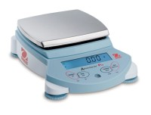 | Ohaus Electronic Balance - 810 g Capacity  Code: 88-1034/02  Product Group: Ohaus Series Electronic Balances  Includes weigh-below hook.

Further Information
100-240V, 50/60 Hz.

Specification
Maximum Capacity | 810 g
Readability | 0.01 g
Repeatability (Std. Dev.) | 0.01 g
Linearity | +/-0.02g
Internal Calibration | NO
Pan Size (in/cm) | 5.8 x 6.3 /  14 .9 x 16.2
Dimensions w x h x d (in/cm) | 7.5 x 2.8 x 10 /  19.3 x 7.2  x 25 .4
Shipping Wt. (lb/kg) | 3.3 / 1.5

