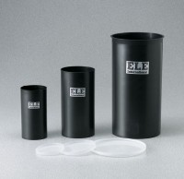 | Plastic Cylinder Mould 3" x 6"  Code: 34-5290  Product Group: Plastic Cylinder Moulds  (76 x 152 mm). Carton of 80

Standards
ASTM C39, ASTM C470, AASHTO M205

