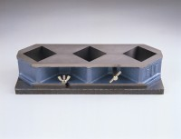 | Three-gang Mould  Code: 39-0410  Product Group: Moulding of 50 mm and 100 mm Specimens  For 50mm mortar cubes. Manufactured from cast iron with simple cube release mechanism.

Standards
BS 1881-131, ASTM C109

Further Information
**NOT AVAILABLE FOR SALE IN THE USA**

