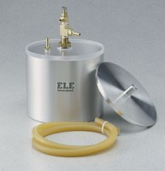 | Vacuum Pyknometer (2,000 gram)  Code: 45-9310  Product Group: Vacuum Pyknometer (2,000 Gram), Specific Gravity (Rice) Test with 2,000 gram Vacuum Pyknometer

Standards
ASTM D2041, AASHTO T209, AASHTO T283

Specification
Capacity | 2,000 g.
Construction | Aluminum.
Dimensions | 7.5” i.d. x 6” d. (190 x 150 mm).
Weight | Net 11.9 lbs. (5.4 kg).

