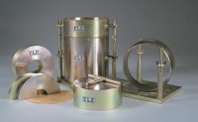 | ASTM Cbr Mould Complete with Collar & Perferated Base  Code: 24-9228  Product Group: ASTM/AASHTO CBR mould and accessories  With collar and perforated baseplate.

Standards
ASTM D1883, AASHTO T193

Specification
Mould | 152.4 x 177.8 mm (inside diameter x height)
Collar | 50.8 mm height, fits both ends of mould
Base plate | Perforated
Construction | All steel, plated
Weight kg | 9

