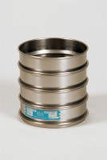 | 12in Dia ASTM Sieve 90 Mic Stainless Steel Mesh.  Code: 79-6050  Product Group: U.S Standard Testing Sieves, 12" Diameter ASTM Sieves, 12" Diameter ASTM Sieves, 12" Diameter ASTM Sieves

Standards
ASTM E11

Specification
Frames | Full height; 3-1/4â (82.5 mm)  depth to mesh.
Construction | Polished and lacquered brass with S.S. mesh.
Nameplates | Show standard, alternate and Tyler Screen Scale equivalent designations.
Weights | Net 4 lbs. (1.8 kg).
Sieve Size or Number | No. 170
Sieve Opening Standard | 90 um
Sieve Opening Alternative (in.) | 0.0035

