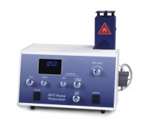 | ELE Flame Photometer  Code: 38-0200/01  Product Group: ELE Flame Photometer  Special Note: The Flame Photometer requires a source of moisture-free air at 6 litres/minute at a pressure of 1 kg/cm². It also requires a fuel source for the flame and a regulator (see accessories).

Standards
EN 196-21, ASTM C114, TEST 17

Further Information
**NOT AVAILABLE FOR SALE IN THE USA**
For 220-240 V AC, 50-60 Hz, 1 ph

Specification
Dimensions (l x w x h) | 420 x 360 x 300 mm
Readout | LED three 12.5 mm digits
Sensitivity Na  K  Ca | 3 to 100 ppm  3 to 100 ppm  5 to 100 ppm (optional filter)
Reproducibility | 1% CV for 20 consecutive samples using 10 ppm, set to read 100
Recorder Output | Nominal 1.00 V for a reading of 100.0
Weight | 8 kg

