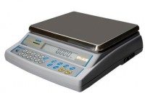 | Electronic Balance - 32 000 g x 1.0 g  Code: 78-5527/01  Product Group: Electronic Balances

Further Information
**Not available for sale in the USA**

Specification
Capacity resolution | 32000 g x 1.0 g
Pan size | 225 x 300 mm
Mains and battery | Yes
Dimensions (l x w x h) | 340 x 320 x 125 mm
Weight | 6 kg

