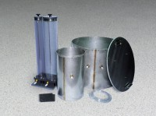 | Double Ring Infiltrometer  Code: 25-0660  Product Group: Double Ring Infiltrometer

Standards
ASTM D3385

Specification
Rings | Aluminum; two included, 12 â i.d. x 20â h. (305 x 508 mm) and 24 â i.d. x 20â h. (610 x 508 mm).
Driving Cap | Aluminum; 1/2â (12 .7 mm) thick; with centering pins.
Splash Guards | Neoprene; two included; 6â (152 mm) square.
Mariotte Tubes | Graduated; two included; 3,000 ml and  10,000 ml capacities.
Weight | Net 70 lbs. (31 .7 kg); Shpg. 90 lbs. (40.8 kg).

