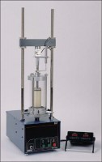 | Versa-Loader  Code: 25-3525/02  Product Group: Versa-Loader, Versa-Loader, Versa-Loader

Standards
ASTM D1883, ASTM D2850, AASHTO T193, AASHTO T296, AASHTO T208

Further Information
110vAC, 50/60 Hz, 1ø.

Specification
Capacity | 10,000 lbf. (45 kN).
Speed Range | 0.001” to 0.08” (0.025 to 2.032 mm) per minute.
Platen Travel | 2.5” (64 mm); limit switch protection.
Vertical Clearance | 33 ” (838 mm) maximum.
Horizontal Clearance | 10” (254 mm).
Controls | Push-button “Up-Down-Stop” with running and travel  limit indicator lights; Speed control knob.
Overall Dimensions | 13 .5” w. x 23 ” d. x 51 ” h. (343 x 584 x 1,295 mm).
Weight | Net 185 lbs. (84 kg).

Spares/Consumables
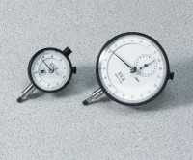 | Dial Indicator - 1.0" Range  Code: 88-4100

