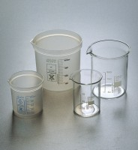 | Beaker - 1000 ml  Code: 82-0220  Product Group: Beakers and Covers  Borosilicate glass, squat form.

Further Information
**NOT AVAILABLE FOR SALE IN THE USA**

