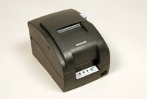 | Portable Impact Tape Printer  Code: 37-4862/02  Product Group: Accu-Tek Touch 350 Series, Accu-Tek Touch 500 Series, Accu-Tek Touch 250 Series  Serial Interface

Further Information
100-240vAC, 50/60 Hz, Global

Spares/Consumables
 | Printer Ink Ribbon Cartridge  Code: 37-4862/11
Printer Paper
Code: 37-4862/10

