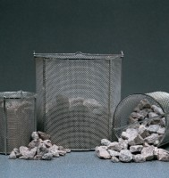 | Wire Basket - 1.18 mm wire mesh  Code: 81-4823  Product Group: Soundness of Aggregates, Wire Baskets

Further Information
**NOT AVAILABLE FOR SALE IN THE USA**

