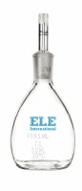 | Glass Specific Gravity Bottle - 100 ml Capacity  Code: 88-6304  Product Group: Glass Specific Gravity Bottles

