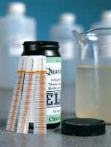 | Quantab Chloride Titrator Strips Type 1176 Titration Range 0.05%-1% (300-6000 ppm) Nacl Pack of 40.  Code: 42-2952  Product Group: Chloride Content: Rapid Method  Type 1176 titration range 0.05% to 1% (300 to 6000 ppm) NaCl. Pack of 40.

Further Information
**NOT AVAILABLE FOR SALE IN THE USA**

