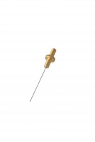 | ASTM Initial Set Needle  Code: 38-2620  Product Group: Vicat Apparatus, Vicat Method  1 mm diameter.

Standards
ASTM C187, ASTM C191

Spares/Consumables
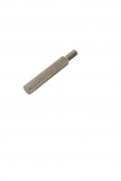 | Consistency Plunger  Code: 38-2010/10

