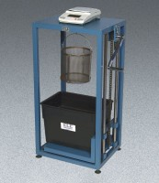 | ELE Buoyancy Balance  Code: 42-1000/02  Product Group: ELE Buoyancy Balance

Standards
ASTM C127, AASHTO T85

Further Information
shown with density basket; not included; order separately.
110-120vAC, 50/60 Hz, 1ø.shown with density basket; not included; order separately.
110-120vAC, 50/60 Hz, 1ø.

Specification
Capacity | 8,100 g.
Construction | Heavy-duty support frame with water tank  and mechanical lifting device. A suspension  hook is included.
Balance | Electronic; 8,100 g capacity x 0.1 g.
Weight | Net 79 lbs. (35.9 kg).

