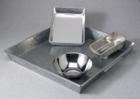 | Mixing Pan - Rectangular Stainless - 21" x 13" x 2"  Code: 88-7120  Product Group: Mixing Pans and Bowls  Stainless steel; 21” x 13” x 2” (525 x 330 x 51 mm).

