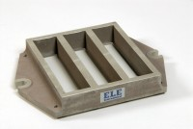 | Feeding Hopper  Code: 39-1120  Product Group: Moulding of Prisms  For 39-1100 Mould.

Further Information
**NOT AVAILABLE FOR SALE IN THE USA**

