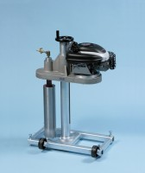 | Compact Core Drill  Code: 47-5175  Product Group: Compact Core Drill Machine  This compact and portable core drilling machine is designed to cut cores up to 150 mm diameter from concrete, asphalt and similar hard construction material.  The machine comprises a vertical support column which carries the drill head/motor assembly.  An integral water swivel is built into the drill head providing a 12 mm connection to an external water supply via 12 mm flexible hose (not supplied). The motor assembly comprises a 4 hp, 2-stroke petrol engine. Speeds of 800 rpm or 1200 rpm may be selected. A ball screw mechanism enables close control over drilling pressure and rapid return when drilling is completed.  The complete assembly is supplied on a rigid metal base frame with levelling facility and is suitable for vertically down drilling applications only.

Standards
EN 12697-32, EN 13280-4, BS 598-104

Further Information
**NOT AVAILABLE FOR SALE IN THE USA**
Special Note: Requires a continuous clean water supply via a 12 mm flexible hose (not supplied).

