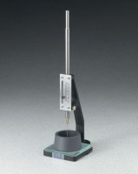 | Vicat Apparatus  Code: 38-2012  Product Group: Vicat Apparatus  Includes Vicat needle and mould.

Standards
ASTM C91, ASTM C187, ASTM C191, AASHTO T129, AASHTO T131

Specification
Plunger | Reversible; 10 mm diam. at one end and 1 mm diam. needle at other end; combined weight 300 grams.
Needle | Steel; mounted in plunger; 1 mm diam. x 50 mm long.
Scale | Graduated in millimeters.
Mold | Hard rubber; 70 mm base diam. x 60 mm top diam.  x 40 mm h.
Weight | Net 4 lbs. (1.8 kg).

